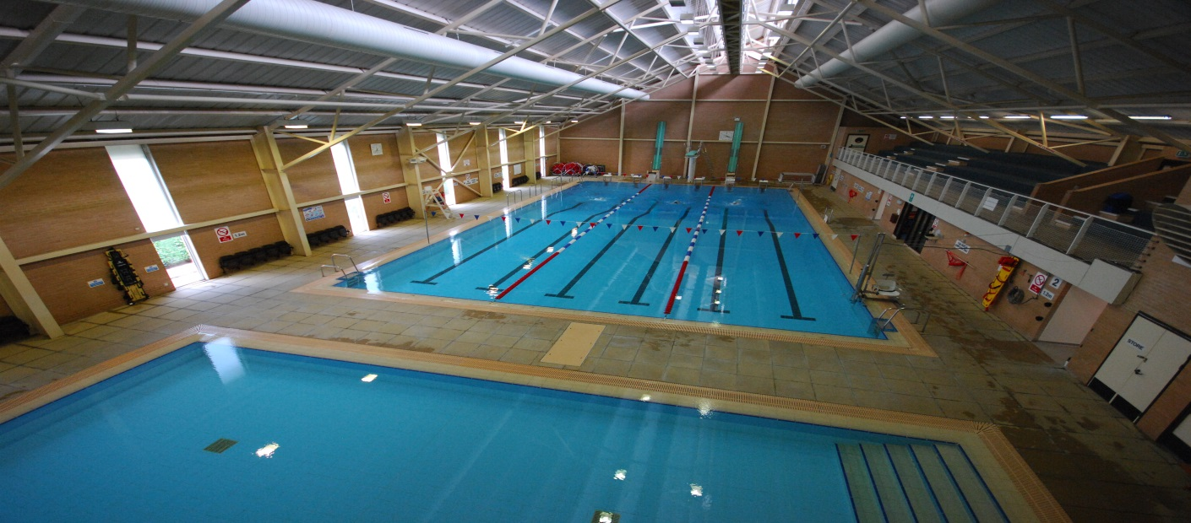

LIFEGUARD (FULL TIME)
BACKGROUND

St Swithun's School, is set on an impressive and attractive campus of 45 acres overlooking open countryside, and offers girls exceptional teaching, sporting and recreational facilities. The school offers day, weekly boarding and full boarding options for some 520 girls aged 11-18. There is an adjoining Junior School for girls aged 3-11 and boys up to the age of 7 years, with a total pupil roll of 200.

PERSON SPECIFICATION

Applicants should
- hold a current NPLQ
- be self-motivated
- be a team player
- have excellent communication skills
- be flexible in their approach to work

JOB DESCRIPTION

The following is not a definitive list but gives an overall view of the work that the lifeguard will undertake:-

- To ensure the comfort, safety and enjoyment of all users of the Centre.
- To maintain vigilant supervision of pool users and ensure their safety at all times.
- To administer first aid, effect pool rescues and carry out resuscitation as necessary.
- To comply with the Centre's Health and Safety procedures at all times.
- To deal with customers in a friendly and professional manner.
- To report any matter of concern to the Duty Manager immediately.
- To carry out cleaning duties as necessary.
- To wear the prescribed staff uniform at all times.
- To wear the personal protective equipment provided when necessary during the course of your duties.
- To carry out patrols of the Centre.
- To ensure that all Centre equipment is stored safely and securely when not in use.
- To report any maintenance issues using the appropriate procedures.
- To assist the Duty Manager with any tasks involved in the operation of the Centre.
- To maintain any suggested training requirements.
- To continually meet the lifeguard key performance indicators and competency standards
- To promote and safeguard the welfare of children and young persons for who you are responsible and with whom you come into contact
- Supporting the teaching staff where necessary

Health and Safety:
As a member of staff you are responsible for your own safety and the safety of your colleagues and customers using the facilities in which you work; you must therefore have knowledge of the Company's Health & Safety Policy and relevant instructions to your area of work. Any matter which you consider requires attention in this respect is your responsibility to report to your manager following the correct procedures, or to the Health and Safety Manager. Copies of the current Health & Safety Policy and Safety Procedures are available in the Centre.

TERMS AND CONDITIONS

- Full time position – 40 hours per week
- Working on a rotating three-weekly shift pattern
- £17,017 per annum (point 14 on the support staff pay scale), calculating at £8.18 per hour.
- 20 days holiday plus bank holidays
- Generous contributory pension scheme
- Free refreshments and breakfast/lunch/supper when on duty and the school kitchen is open
- Use of the swimming pool

Applications should be addressed to:

HR Office
St Swithun’s School
Alresford Road
Winchester
SO21 1HA

email: hr@stswithuns.com
website: www.stswithuns.com

All applications must be received by: 05 March 2018
Interviews: Week beginning: 12 March 2018

****

Child Protection Policy Statement

St Swithun’s is committed to safeguarding and promoting the welfare of children. All staff are expected to share and support this commitment and applicants must be willing to undergo child protection screening appropriate to the post, including checks with past employers and the Disclosure & Barring Service

